Logo:

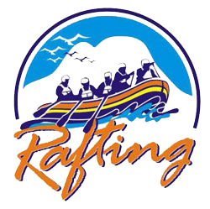

colors:

primary-color #0257CF

secondary-color #B360C3

accent1-color #6A4D4D

accent2-color #4DFA70

color palate URL:

https://coolors.co/6a4d4d-345995-e40066-b360c3-fb4d3d-4dfa70-fb6c5f-fb796e-fb857b-fb9087

heading-font - Playwrite Deutschland Grundschrift

text-font - Comfortaa